Group 5 – Software Engineering Project- Property Tycoon Testing Report
Date: 09/04/2025
We have tested our game and the code in multiple ways to ensure we know the most things in our game.
Here is the test we used to test and the result:
- Unit Test:
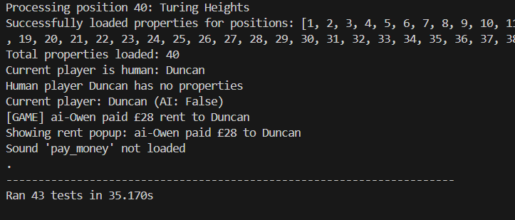

Edge cases
However, because we had a plan and considered avoiding it at the beginning when we did coding, we didn't find many edge cases that would make our game bug in the unit test with 43 test cases.

- Level testing:
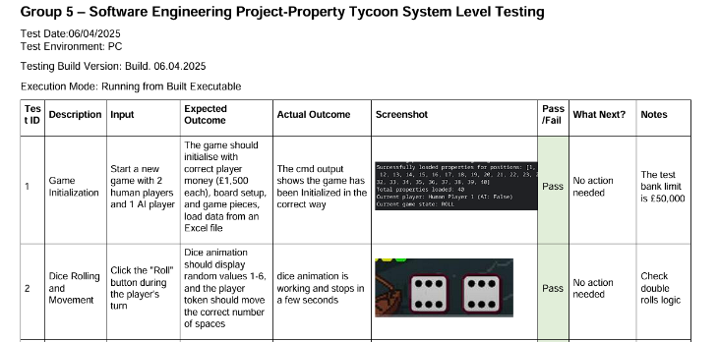
We do find some bugs here
We have created 2 Level testing Doc

card and property late one-round show bug

- Game play Testing Debug log:
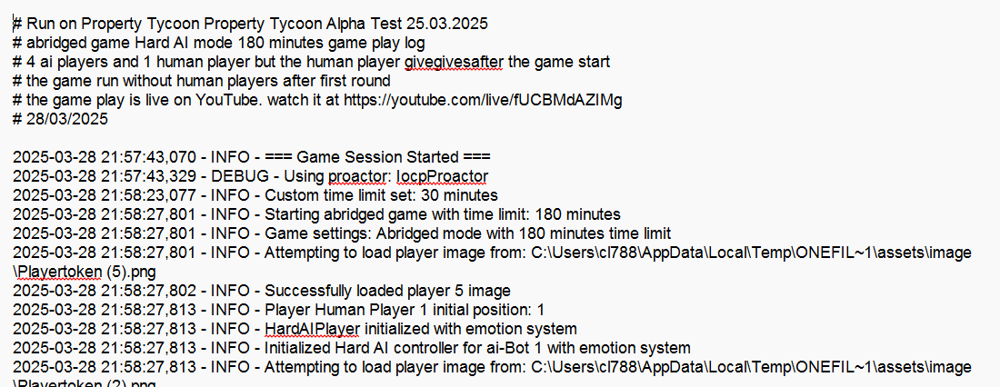
Added a lot of debug print into the game by looking at the game progress to find bugs
found in game play:
Known bug:
Bid
Late one round
Dev mode
Reason:

- Semantic and stylistic Test with Lint:
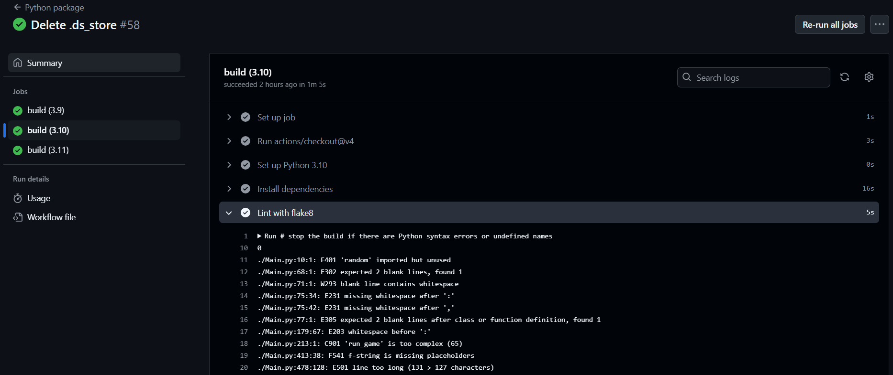https://en.wikipedia.org/wiki/Static_program_analysis
https://en.wikipedia.org/wiki/Lint_(software)

PEP 8 style guidelines and avoids common coding mistakes.
https://docs.github.com/en/actions/use-cases-and-examples/building-and-testing/building-and-testing-python

- Test Code security results:
Screen short from Github
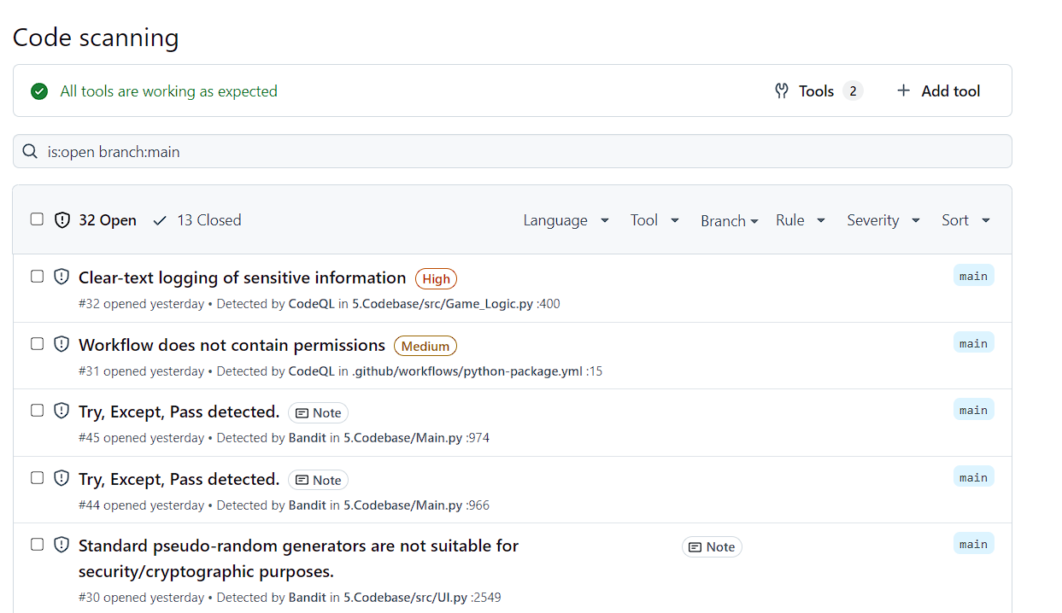
Screen short from VScode with
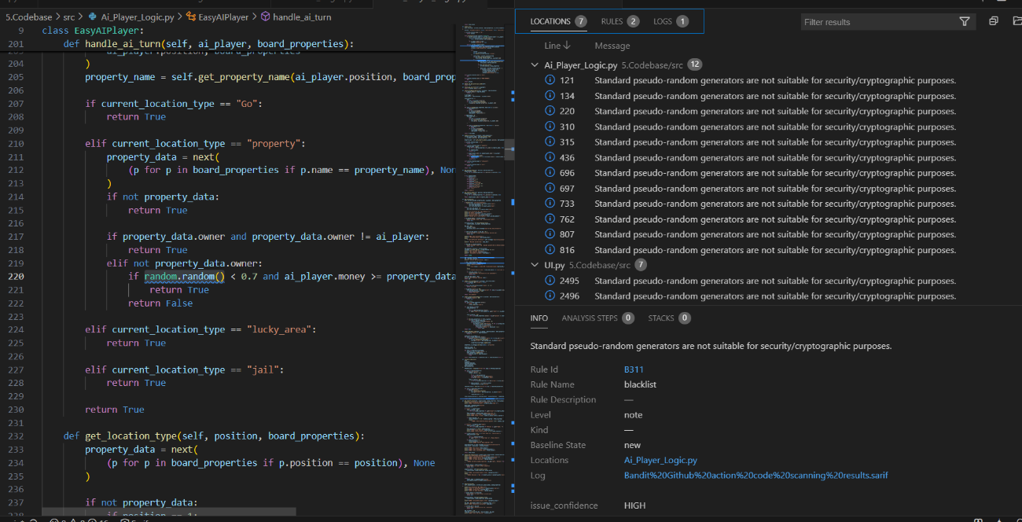
https://github.com/PyCQA/bandit Github
https://github.com/Minosaji/Software-Engineering-Project/actions/workflows/bandit%20security%20linter.yml

a code scanning result (in the format of a . SARIF file) using GitHub Actions.
https://marketplace.visualstudio.com/items/?itemName=MS-SarifVSCode.sarif-viewer

- Continuous Integration (CI)test using GitHub Actions
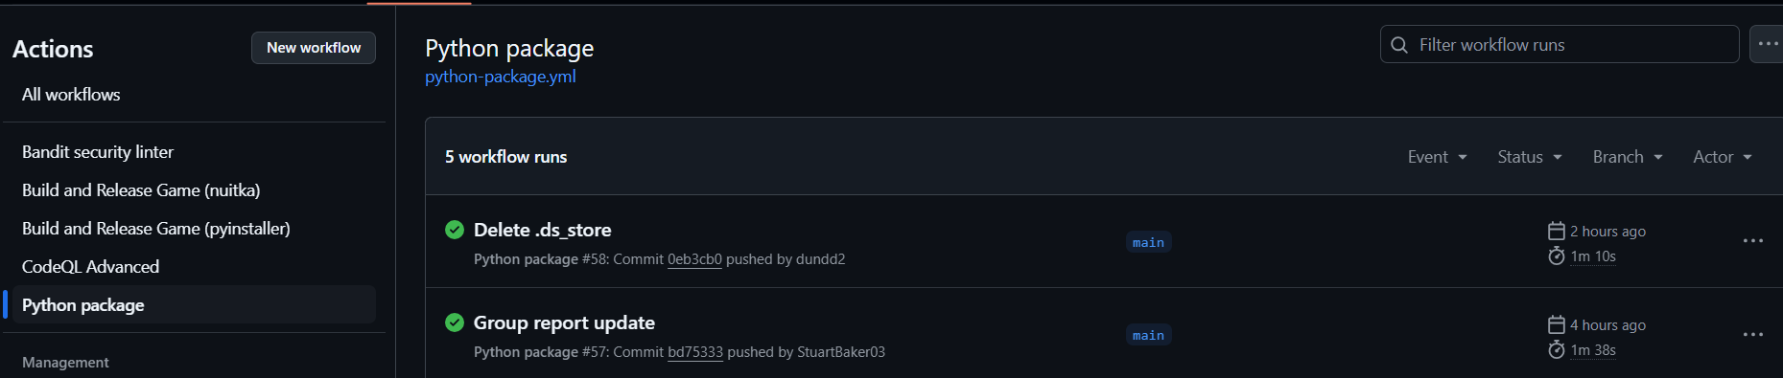
https://github.com/Minosaji/Software-Engineering-Project/actions/workflows/Build,ReleaseGame(pyinstaller).yml
python-package.yml install Python dependencies, run tests and lint with a variety of Python versions

